**Install SQL Server 2019 Developer Edition**

**Download SQL Server 2019**

To download SQL Server 2019, you click the following link:

[Download the SQL Server](https://www.microsoft.com/en-us/sql-server/sql-server-downloads)

Microsoft provides you with some SQL Server editions. For learning purposes, you can download the Developer edition.

Once complete downloading, you can double-click the file **SQL2019-SSEI-Dev.exe** file to launch the downloader.

1. The downloader will ask you to select the installation type, choose the Download Media option. This option allows you to download the setup files first and install the SQL Server later.

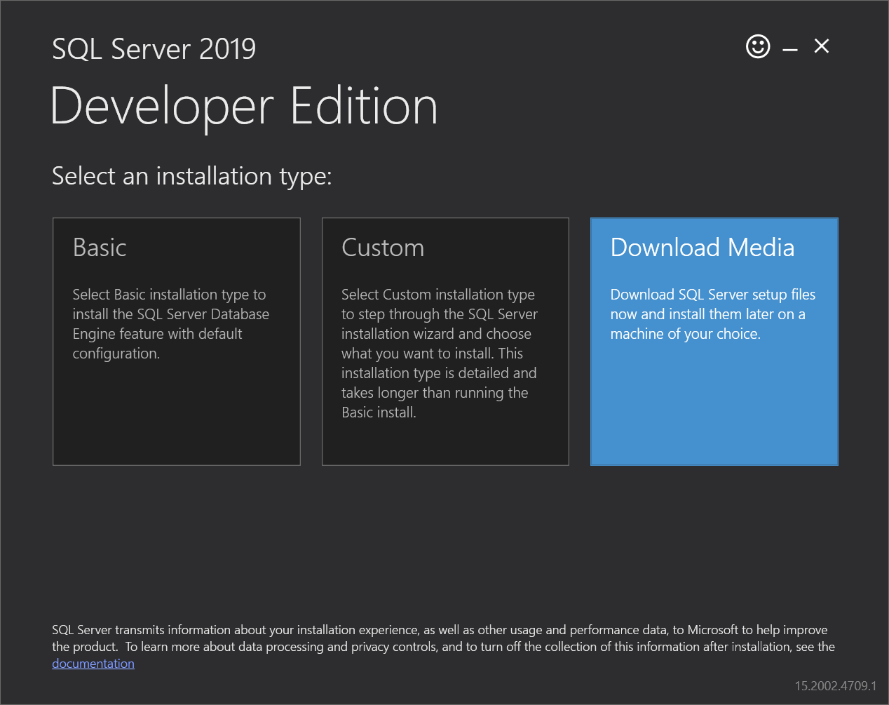

2. Specify the folder for storing the installation files, then click the Download button:

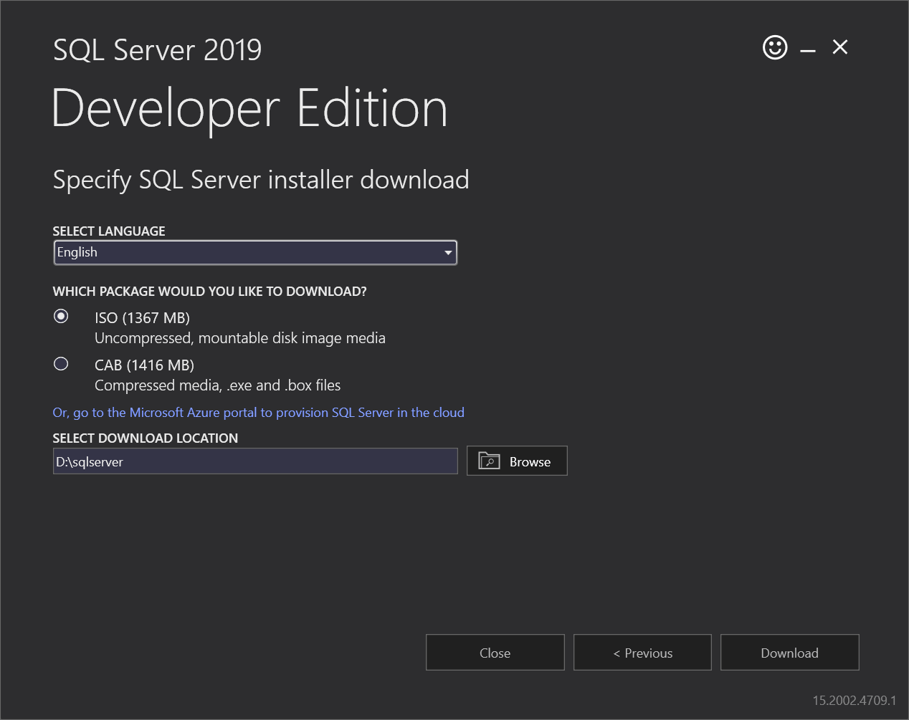

3. The downloader will start downloading the installation files. It’ll take a while.

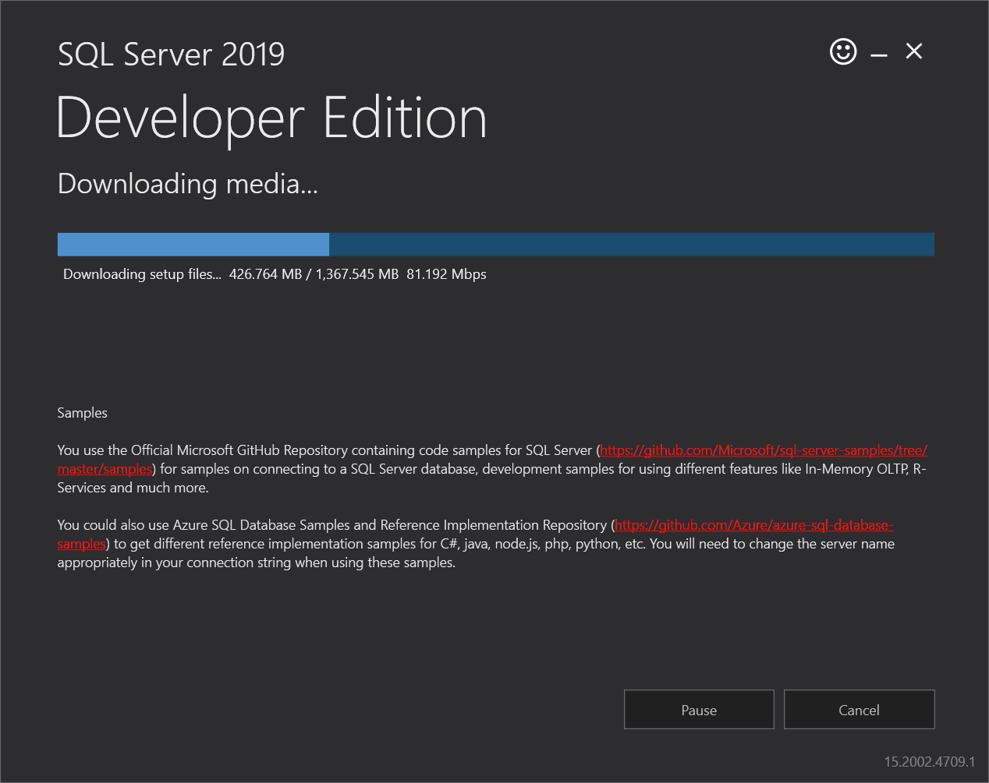

4. Once the download completes, open the folder that stores the downloaded file:

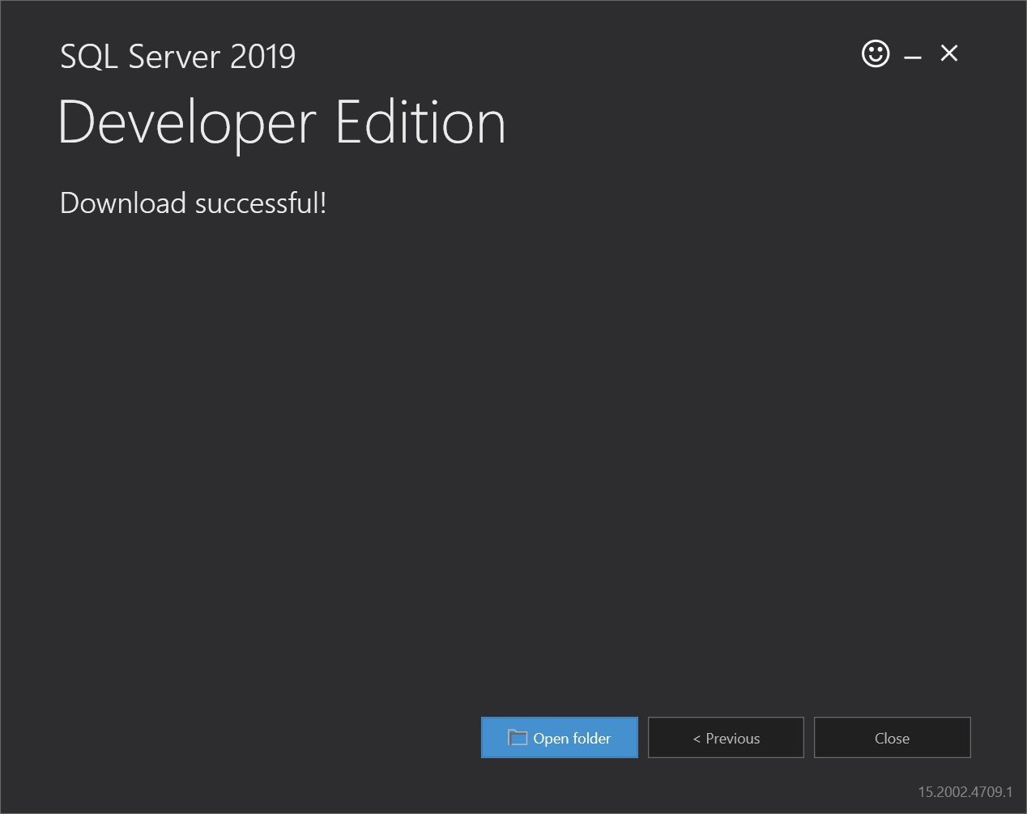

5. Right-click the iso file and select the Mount option to mount the iso file:

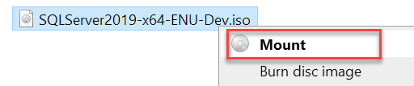

6. Open the installation folder and click the **setup.exe** file to launch the installer:

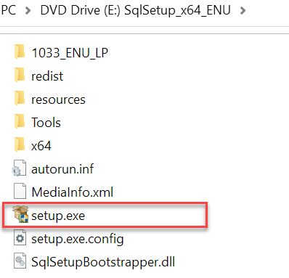

**Install SQL Server 2019 developer edition**

1. After double click setup.exe, you’ll see the following window; select the installation option on the left:

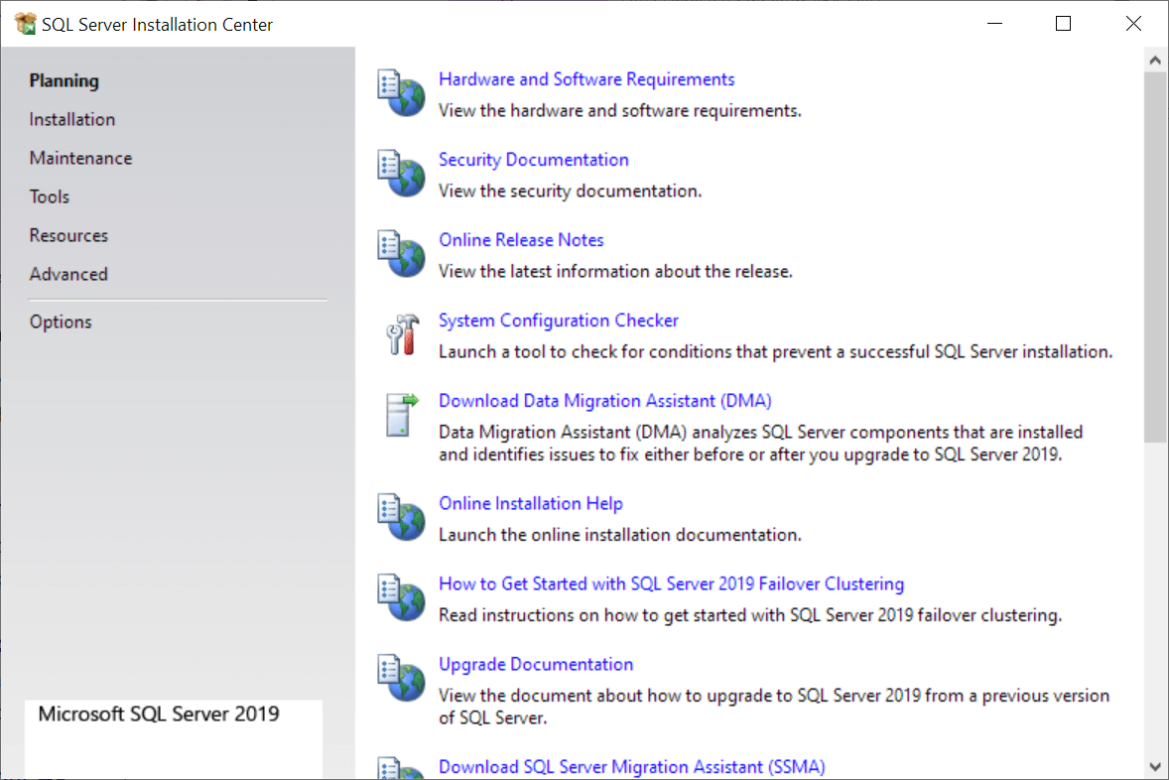

2. Click the first link to launch a wizard to install SQL Server 2019:

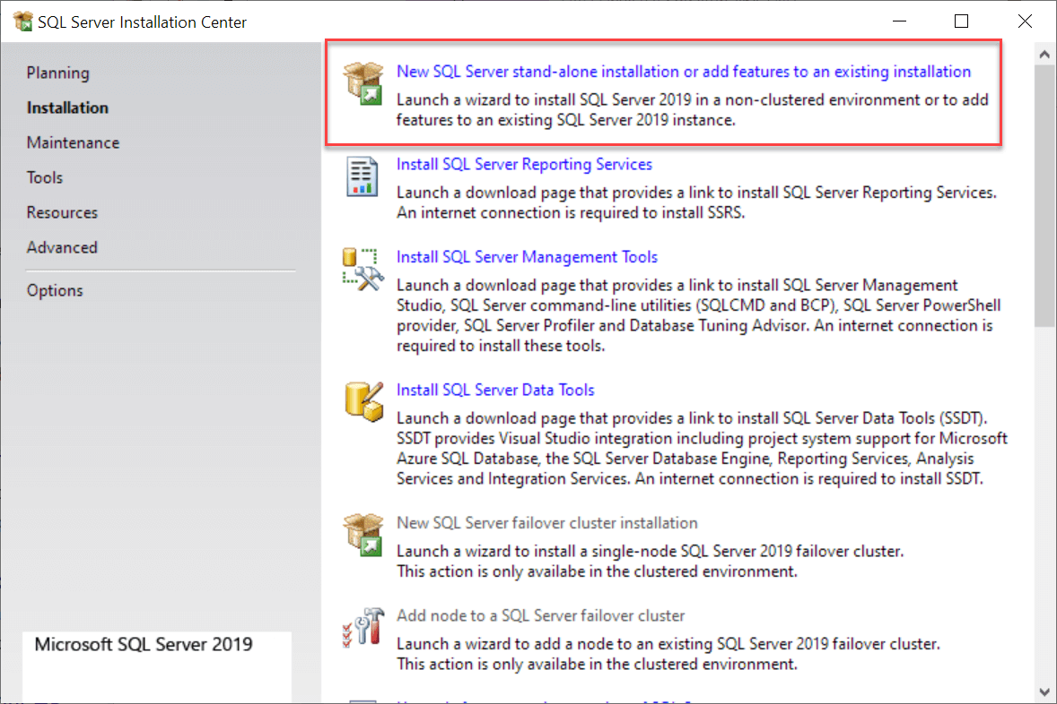

3. Specify the edition that you want to install, select Developer edition, and click the Next button.

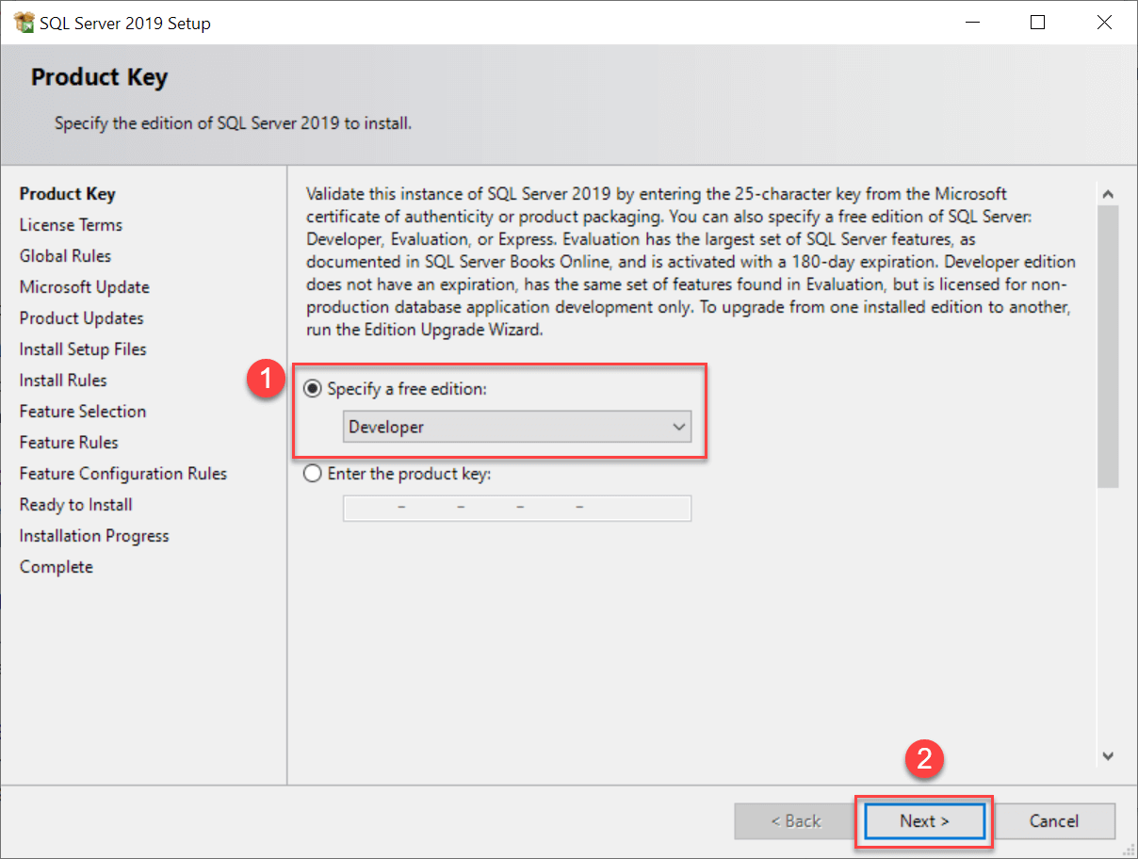

4. Select the “I accept the license terms.” and click the Next button:

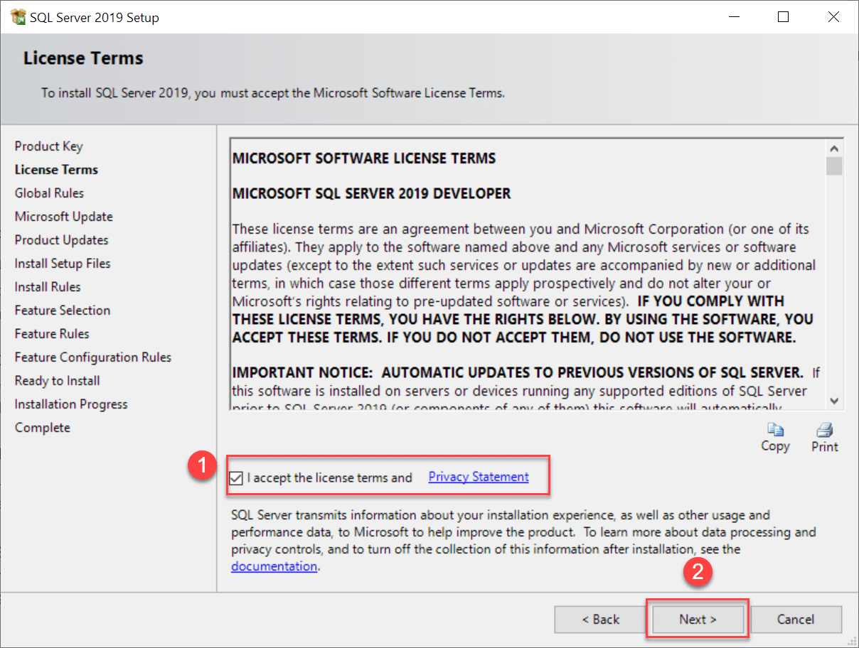

5.  Uncheck the “Use Microsoft Update to check for updates (recommended)” if you don’t want to get the updates for the SQL Server and click the Next button:

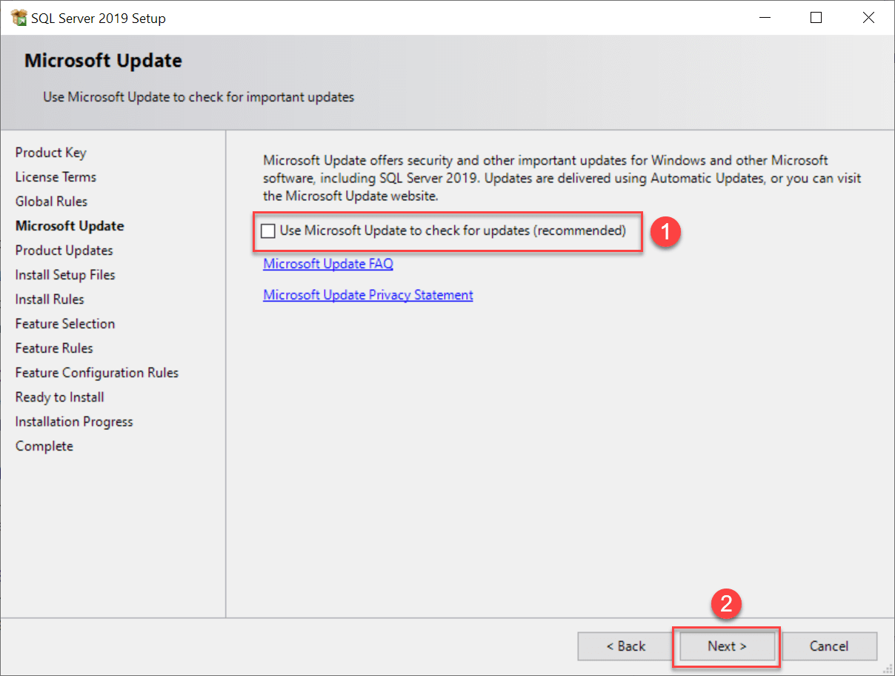

6. The installation checks for the prerequisites before installation. If no error occurs, click the Next button:

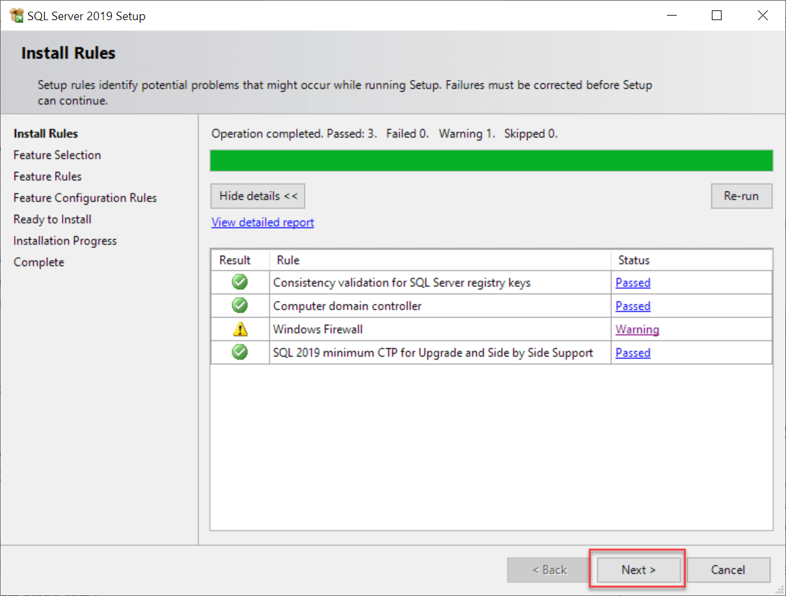

7. Select the features that you want to install. For learning purposes, you need the Database Engine Services; check the checkbox and click the Next button to continue:

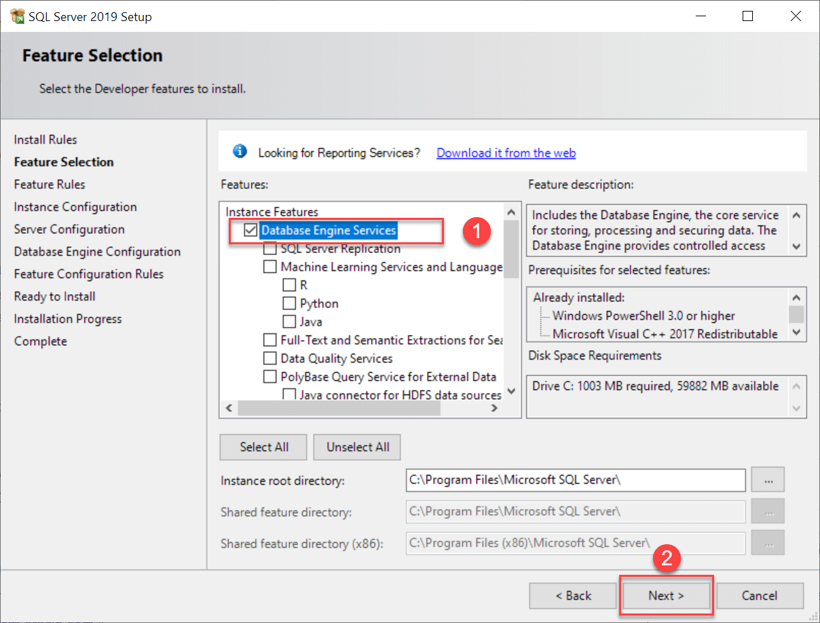

8. Provide the instance ID of the SQL Server and click the Next button:

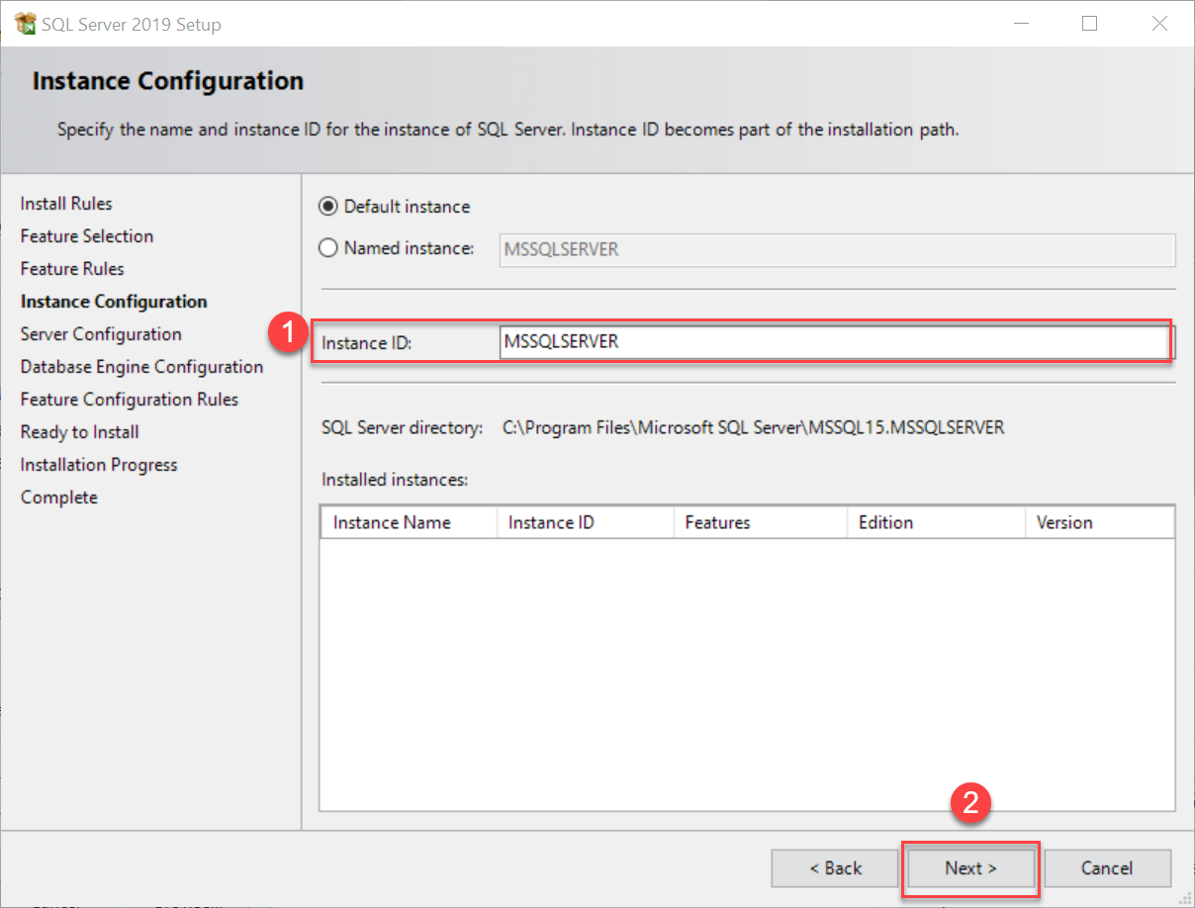

9.  Select the Mixed Mode, provide the password for system administration (sa) account (you need to store this password in a secure place so that you can use it to connect to the SQL Server later), click the Add Current User to specify the SQL Server Administrators, and click the Next button:

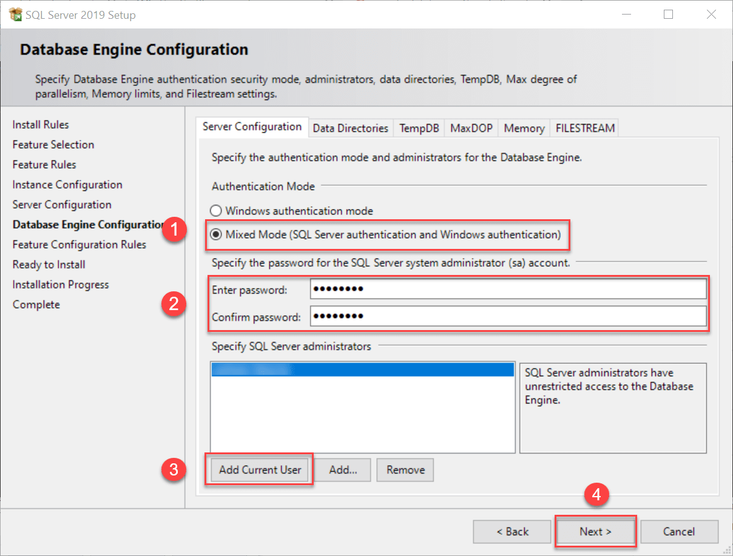

10. Verify the SQL Server 2019 features to be installed:

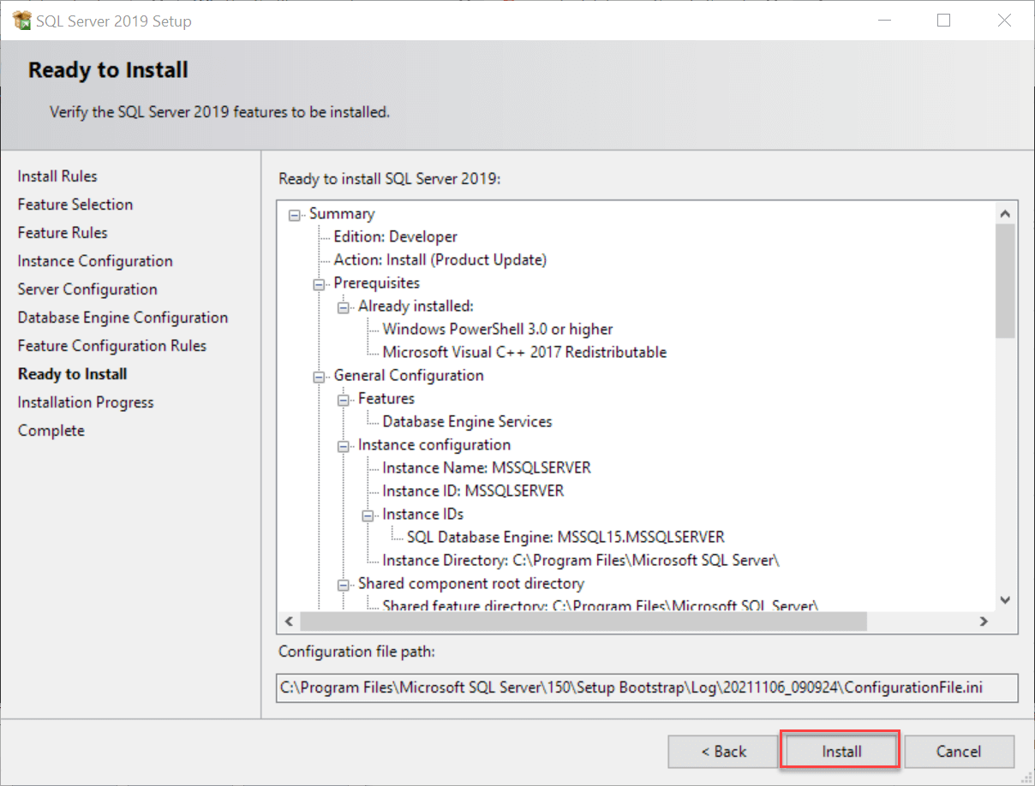

11. Click the Close button to complete the installation:

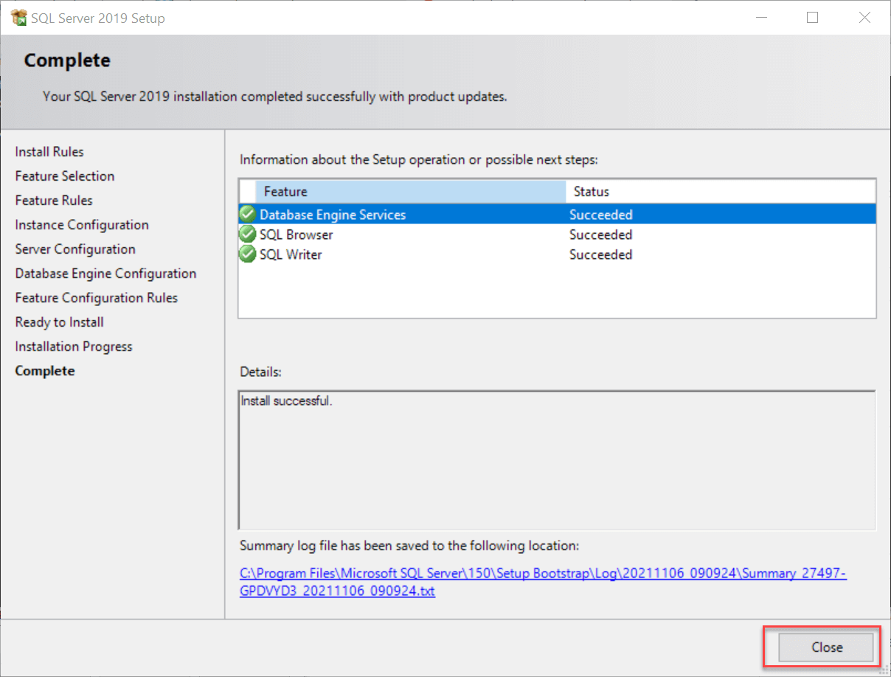

Congratulation!  you have successfully installed SQL Server 2019 Developer Edition.

**Install Microsoft SQL Server Management Studio**

To interact with SQL Server, you need to have a SQL Server client tool.

Microsoft provides you with the SQL Server Management Studio (SSMS). The SQL Server Management Studio is software for querying, designing, and managing SQL Server on your local computer or in the cloud. It provides you with tools to configure, monitor, and administer SQL Server instances.

First, download the SSMS from the Microsoft website via the following link:

[Download SQL Server Management Studio](https://docs.microsoft.com/en-us/sql/ssms/download-sql-server-management-studio-ssms)

Second, double-click the installation file **SSMS-Setup-ENU.exe** to launch the SSM installer. The installation process of SMSS is straightforward. you need to follow the screen sequence.

1. Click the **Install** button

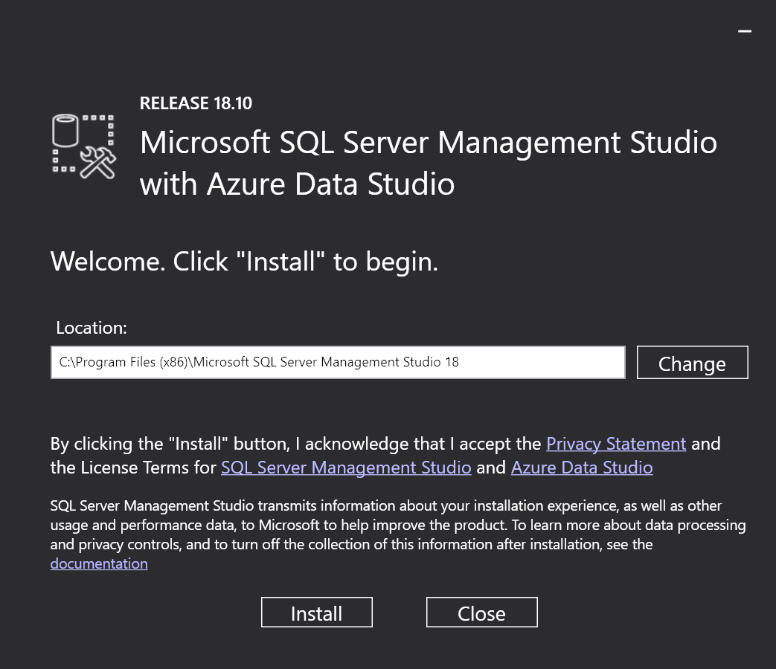

2. Wait for a few minutes while the installer sets up the software:

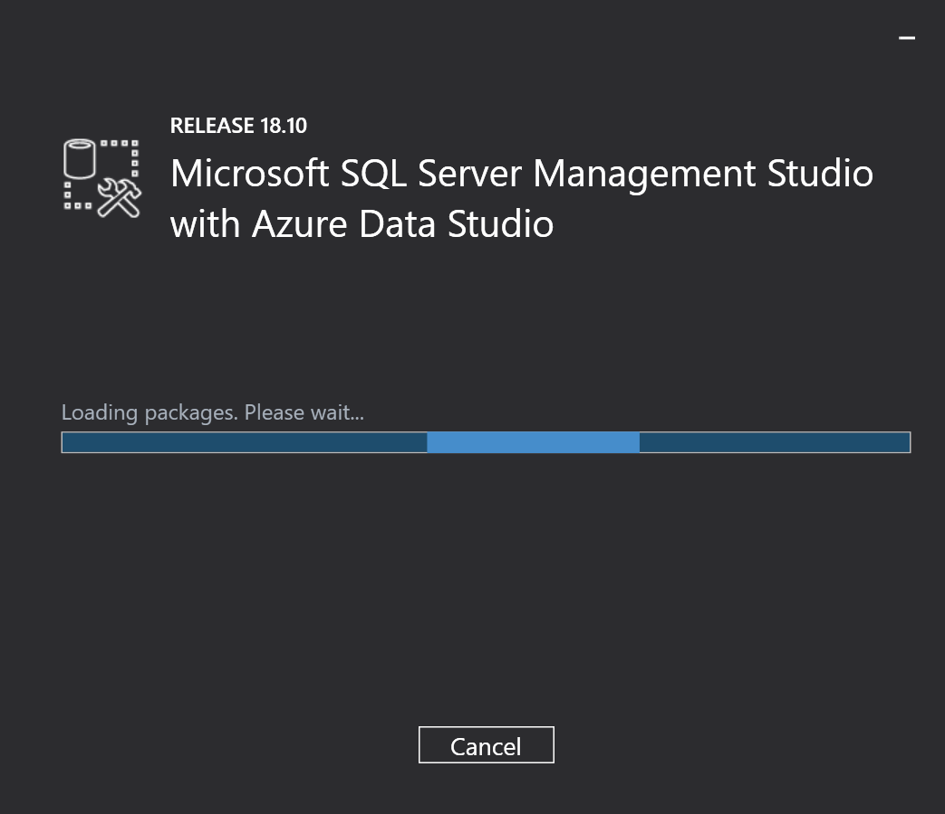

3. Once setup is completed, click the **Close** button:

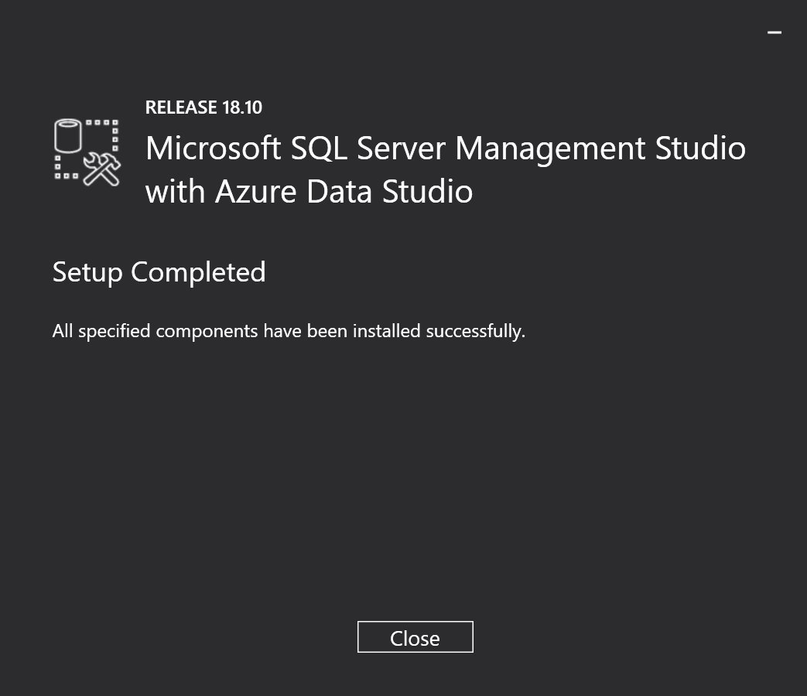

Now, you should have SQL Server 2019  and SQL Server Management Studio installed on your computer.